File Handling in Python
File handling in Python is used to store and manipulate data in files. Python has several functions and modules that make file handling easy. Python also supports various file types like text files (.txt), binary files (.bin), and many more.
File Operations:
There are several basic file operations in Python, including:
- Opening a file
- Reading from a file
- Writing to a file
- Closing a file
- Appending to a file

  - Opening a File

In Python, the open() function is used to open a file. It returns a file object, and it's commonly used with two arguments:
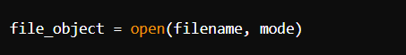

filename: The name or path of the file.
mode: The mode in which the file should be opened.

File Modes:
- "r": Read (default mode). Opens the file for reading. Raises an error if the file does not exist.
- "w": Write. Opens the file for writing. Creates a new file if it doesn't exist or truncates the file if it exists.
- "a": Append. Opens the file for appending. Creates a new file if it doesn't exist.
- "x": Create. Creates a new file. Raises an error if the file already exists.
- "b": Binary mode. Opens the file in binary mode (for non-text files like images).
- "t": Text mode (default mode). Opens the file in text mode (for text files).
- "+": Read and write. Opens the file for both reading and writing.
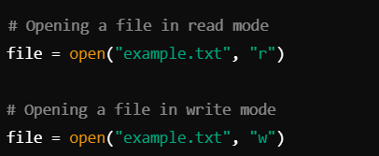

Reading from a File
Python provides various methods to read from a file:
- read(): Reads the entire content of the file as a string.
- readline(): Reads one line from the file.
- readlines(): Reads all lines of the file and returns them as a list of strings.
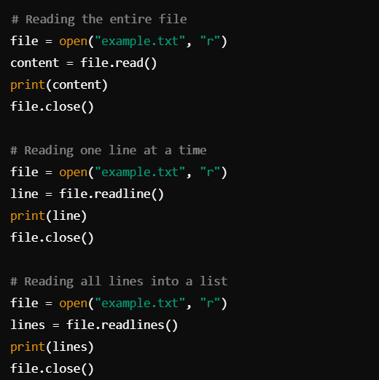
Writing to a File
There are two primary methods for writing to a file:
- write(): Writes a string to the file.
- writelines(): Writes a list of strings to the file.
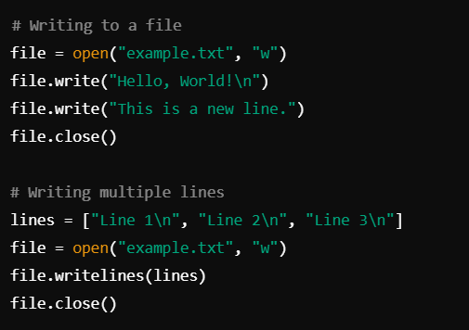

Appending to a File
To append new content to an existing file without overwriting it, use the "a" mode.
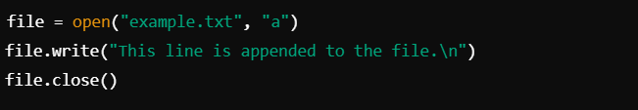

Closing a File
It's important to close a file after you're done working with it. This ensures that resources are freed and changes are saved.
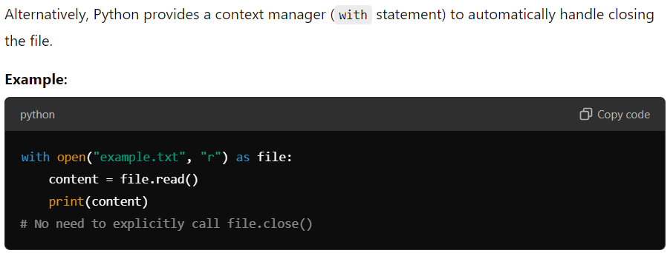
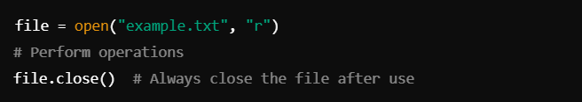

File Pointer
The file pointer indicates the current position where reading or writing will happen in the file. Some methods to manipulate the file pointer include:
- seek(offset, from_what): Moves the file pointer to a specific position.
  - offset: Number of bytes to move.
  - from_what: Starting point (0 = start of the file, 1 = current position, 2 = end of the file).
- tell(): Returns the current position of the file pointer.
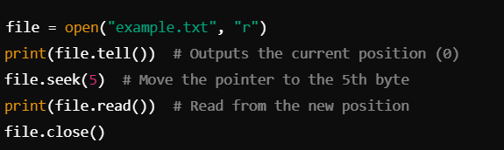
Binary File Handling
For non-text files like images or audio files, use binary mode "b". File operations on binary files work similarly to text files.
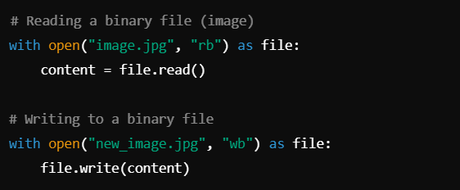

File Handling Functions
- os.remove(): Deletes a file.
- os.rename(): Renames a file.
- os.path.exists(): Checks if a file exists.
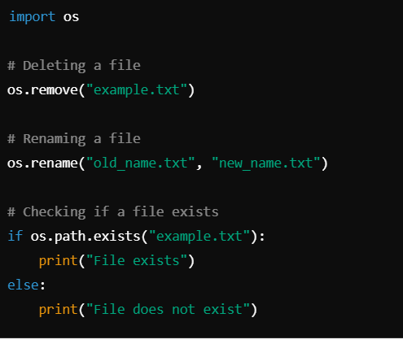

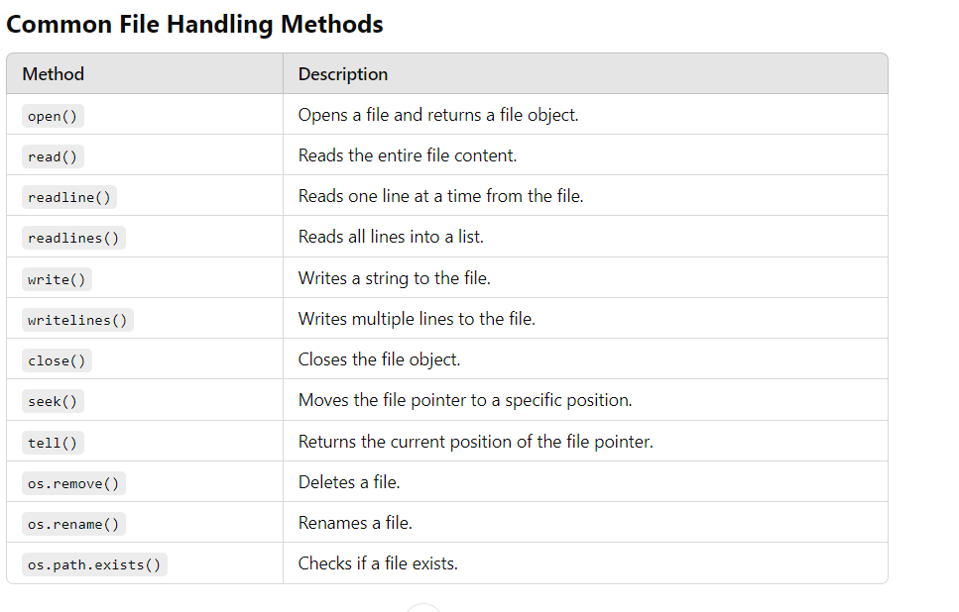
Practical Use Cases
- Logging System:
  - Append log entries to a file using file handling to track application activity.
- Reading Configuration Files:
  - Read configuration settings for an application from a text file.
- CSV File Processing:
  - Handle comma-separated values (CSV) files for data storage and manipulation.
- Data Persistence:
  - Save user preferences, application states, or temporary data to a file.
- File-based Data Storage:
  - Storing data in text or binary files when using a full-fledged database isn't necessary.

